INPUT(SJF PRE-EMPTIVE)

#include <stdio.h>

int main()

{

int arrival_time[10], burst_time[10], temp[10];

int i, smallest, count = 0, time, limit;

double wait_time = 0, turnaround_time = 0, end;

float average_waiting_time, average_turnaround_time;

printf("\nEnter the Total Number of Processes:\t");

scanf("%d", &limit);

printf("\nEnter Details of %d Processes\n", limit);

for(i = 0; i < limit; i++)

{

printf("\nEnter Arrival Time:\t");

scanf("%d", &arrival_time[i]);

printf("Enter Burst Time:\t");

scanf("%d", &burst_time[i]);

temp[i] = burst_time[i];

}

burst_time[9] = 9999;

for(time = 0; count != limit; time++)

{

smallest = 9;

for(i = 0; i < limit; i++)

{

if(arrival_time[i] <= time && burst_time[i] < burst_time[smallest] && burst_time[i] > 0)

{

smallest = i;

}

}

burst_time[smallest]--;

if(burst_time[smallest] == 0)

{

count++;

end = time + 1;

wait_time = wait_time + end - arrival_time[smallest] - temp[smallest];

turnaround_time = turnaround_time + end - arrival_time[smallest];

}

}

average_waiting_time = wait_time / limit;

average_turnaround_time = turnaround_time / limit;

printf("\n\nAverage Waiting Time:\t%lf\n", average_waiting_time);

printf("Average Turnaround Time:\t%lf\n", average_turnaround_time);

return 0;

}

OUTPUT

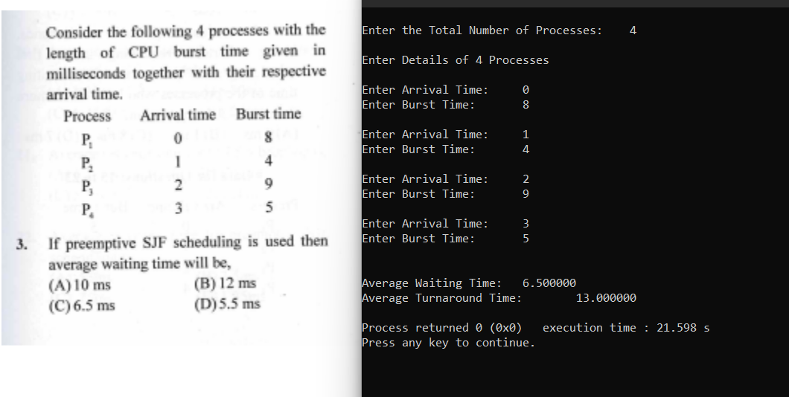

Y. SHAMIL AHAMED

1BM21CS248